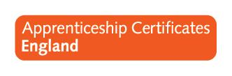 |  | Report request form

what style of report are you requesting?
☐ | Standard Excel export.
☒ | Chart(s)
☐ | Data breakdown

What information do you need?
Please select the required fields from the boxes below. N.B. Candidate Number and Name are standard fields which will be included in all reports.
 | Report fields
☐ | Gender
☐ | Date of Birth
☐ | Ethnicity
☐ | Start Date
☐ | Completion Date
☐ | Certification Date
☐ | Framework
☐ | Level
☐ | Pathway
☐ | Employer Name
☒ | Provider Name
☐ | Other, please specify below:
 | User ID
Please note that we cannot guarantee to provide fields requested in the “Other” section.
Please specify the Data Analysis you require in the field below i.e. Apprentice by Framework etc.
 | Number of Submissions by User

What data restrictions do you need?
☒ | Limit the data to a particular centre/body/status etc. Provide details below
 | Federation Training
☐ | Limit the data to a particular time period i.e. March/2013/the last six months. Provide details below

